BASICS OF CIVIL ENGINEERING

**MODULE 3**

### SUSAN ANN ROY



# Placeholder image

## Syllabus

* **Building Construction**: **Foundations**: Bearing capacity of soil (definition only), functions of foundations, types – shallow and deep (brief discussion only). Load bearing and framed structures (concept only).
* **Brick masonry**: - Header and stretcher bond, English bond & Flemish bond random rubble masonry.
* **Roofs and floors:** - Functions, types; flooring materials (brief discussion only).
* **Basic infrastructure services**: MEP, HVAC, elevators, escalators and ramps (Civil Engineering aspects only), fire safety for buildings.
* **Green buildings:-** Materials, energy systems, water management and environment for green buildings. (Brief discussion only).

BUILDING CONSTRUCTION ( FOUNDATION )

[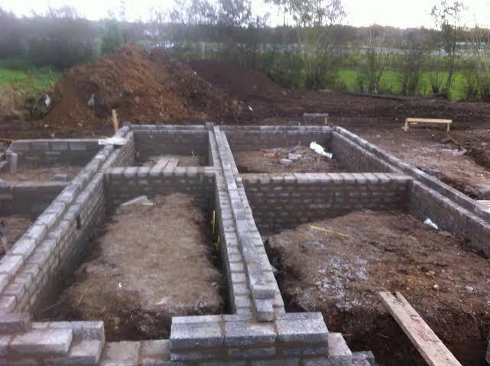](https://www.google.com/search?safe=active&q=brick+foundation#imgdii=KZDVfZA-e8oWGM&imgrc=VT5EV7LdPvmcTM)

### Foundation

* Foundation is that part of the building below the ground that transfers and distributes the load of the building into the ground.
* The solid ground on which the foundation rests is called the Foundation Bed or Foundation Soil which ultimately bears the load and interacts with the foundation of the building.
* Hence the soil supporting the building must be strong enough to carry the super imposed loads.
* Suitable foundation is selected based on the type of soil, depth of bedrock, elevation of groundwater etc.

### Safe Bearing Capacity of Soil

* The ability of the soil to support the super imposed loads without any excessive settlement or failure is known as Bearing Capacity of soil
* The gross pressure intensity at which the soil fails is called Ultimate Bearing Capacity.
* The maximum pressure which the soil can carry without failure is known as Safe Bearing Capacity.
* 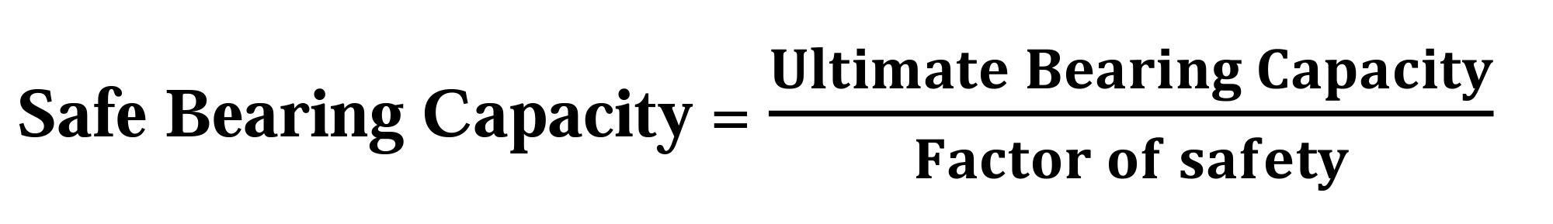

### Functions of foundation

* Provides a level surface for the construction of superstructure
* It spreads the load coming over to the larger area at a uniform rate so that the load coming over the foundation soil does not exceed the safe bearing capacity.
* Foundation transfers the non uniform load of the superstructure evenly to the subsoil, thereby minimizing differential settlement.
* Provides safety against the undermining, scouring flood water and burrowing animals.
* Provides safety against sliding, overturning etc

### Types of foundations

* **Shallow Foundation** - If the width of the foundation is greater than the depth, the foundation is referred to as Shallow Foundation. They are used for small, light buildings and when the hard soil layer is found at a shallow depth.
  + **Isolated / Column Footing**:

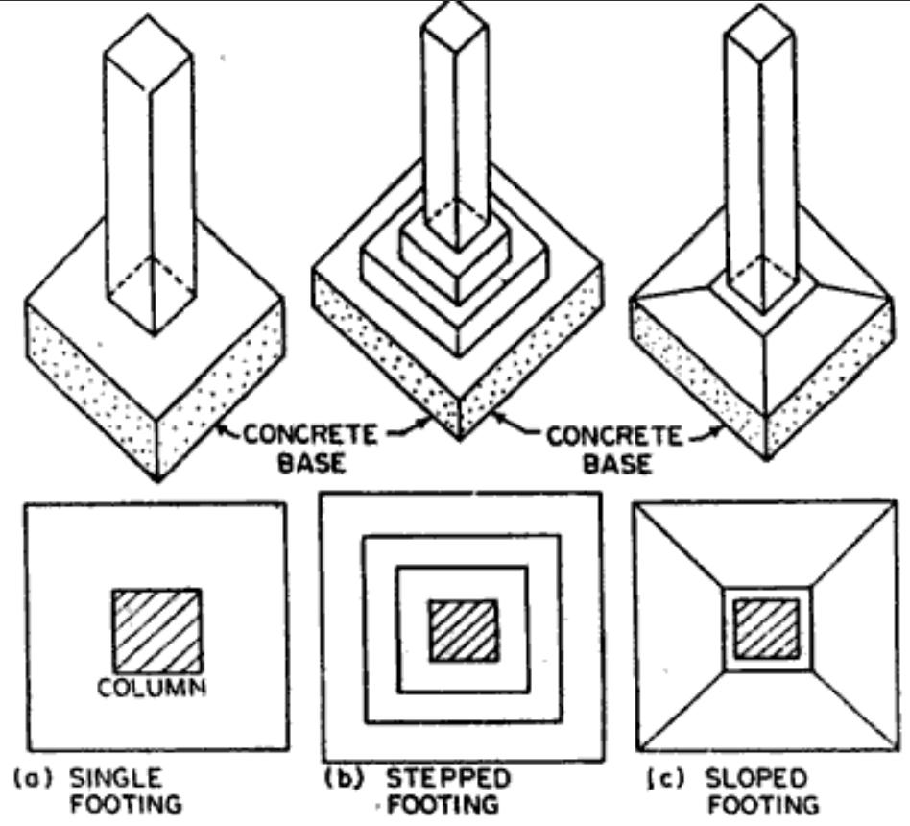

* + - If separate footings are provided for each column, it is called Isolated/ Column Footing.
    - They are again classified as
      * **Simple Isolated Footing**
      * **Stepped Isolated Footing**
      * **Sloped Isolated Footing**
  + **Wall Footing**:

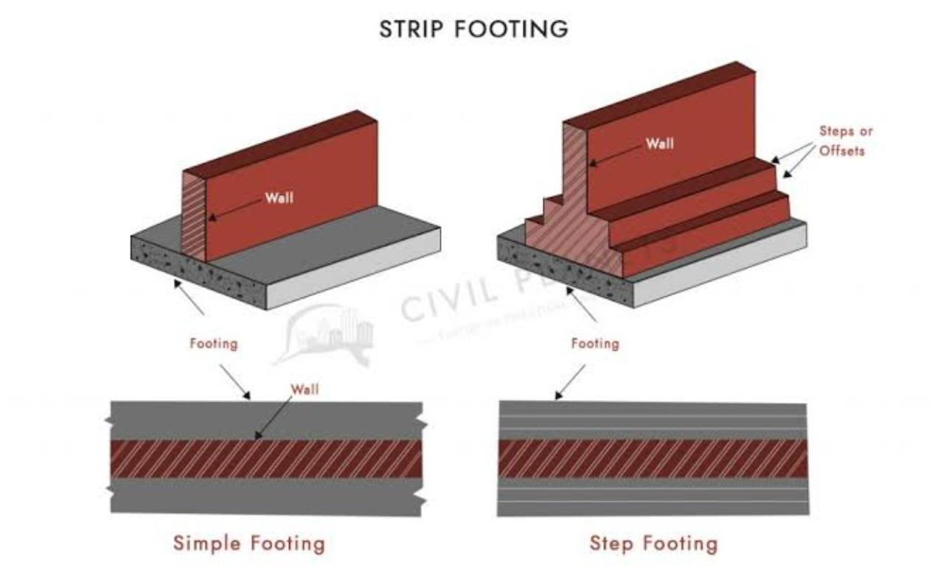

* + - Footing provided under a wall is known as wall footing.
    - They are classified as
      * **Simple Wall Footing and**
      * **Stepped Wall Footing**
  + **Continuous Footing:**
  + 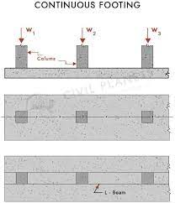

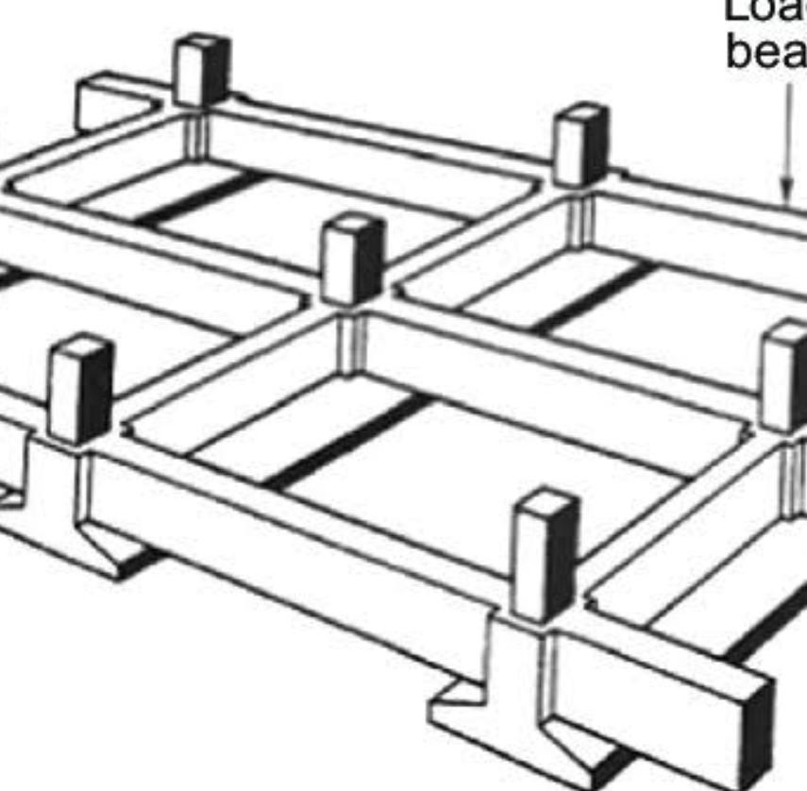

* + - A single RCC slab acting as foundation for two or more columns. Such types of foundation are known as Continuous Footing.
  + **Combined Footing:**

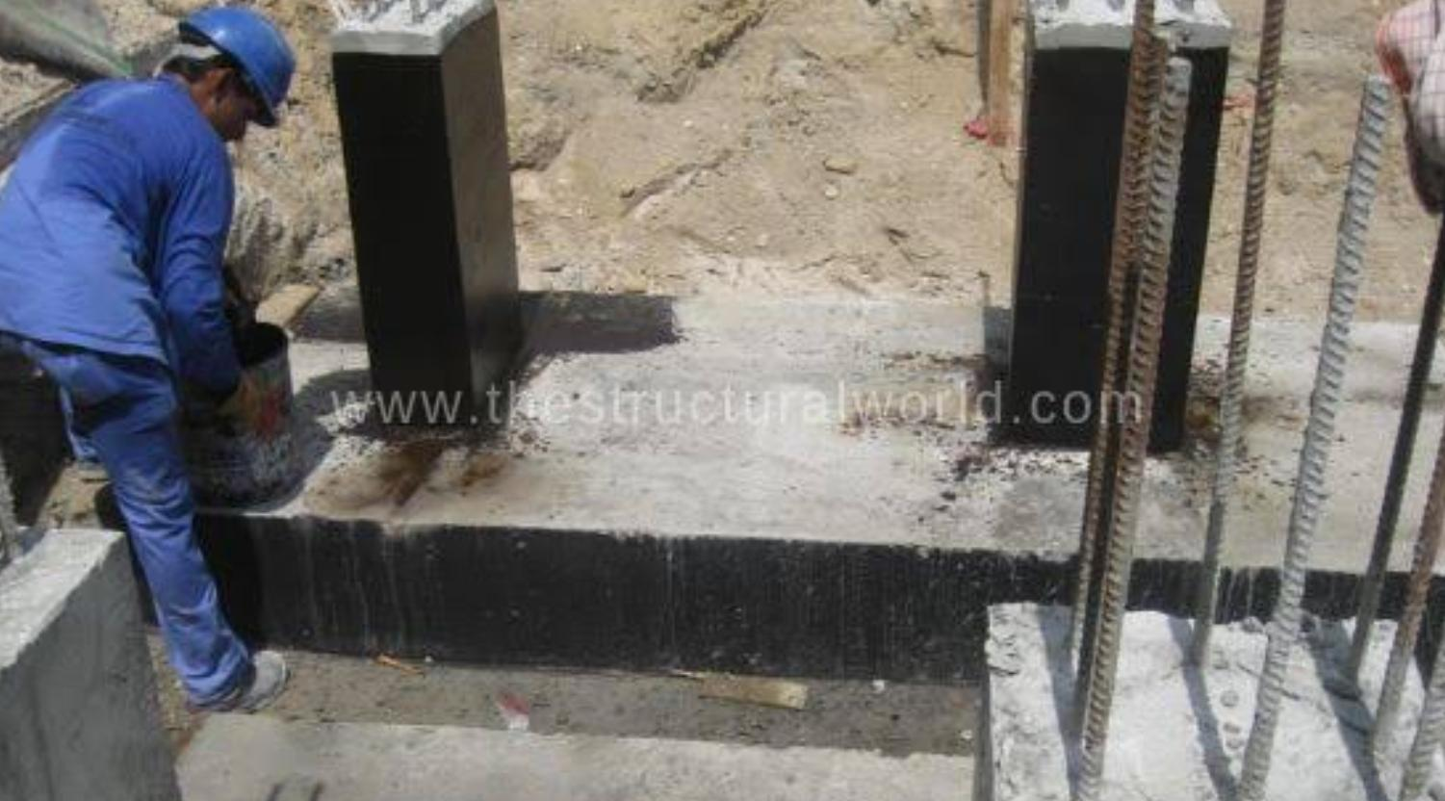

* + - Footings constructed for two or more columns in common are known as Combined Footing.
    - This type of footing is necessary when a column is very close to the boundary of the property or when the construction of the individual footings overlaps.
    - They are again classified as
      * Rectangular Combined Footing
        + Rectangular in plan
        + Adopted when all columns carry equal load
      * Trapezoidal Combined Footing.
        + Trapezoidal in plan
        + Adopted when columns carry unequal loads

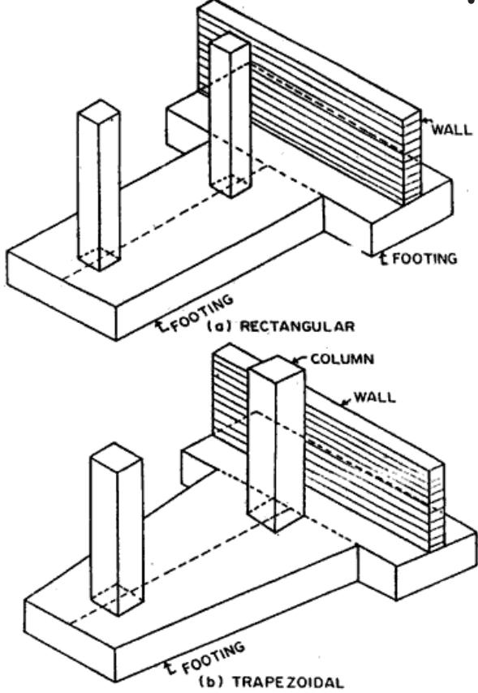

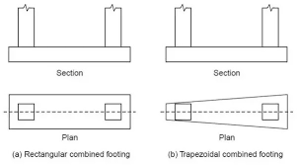

* **Deep Foundation** - If the depth of the foundation is greater than the width, the foundation is referred to as Deep Foundation. They are used when the hard soil layer is at a great depth from the ground level.
  + **Pile Foundations**

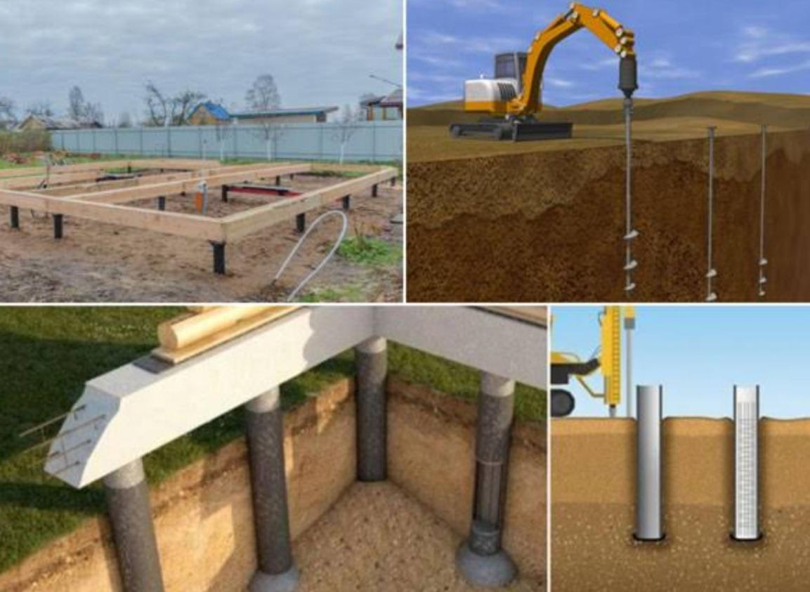

* + - It is a deep foundation used for buildings if heavy loads are to be transferred through the soil strata of low bearing capacity.
    - Piles may be defined as long vertical members made of timber, steel, concrete or RCC.
  + **Pier Foundations**

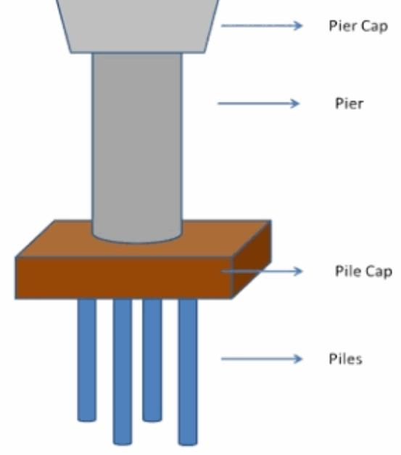

* + - They are used when hard strata are available at reasonable depth.
    - Pier foundation is shallow than pile foundation and it is cast in situ type.
    - It is a huge cylindrical masonry or a hollow vertical shaft filled with inert material.
    - It is used as the foundation of bridges, towers etc.
  + **Well Foundations**

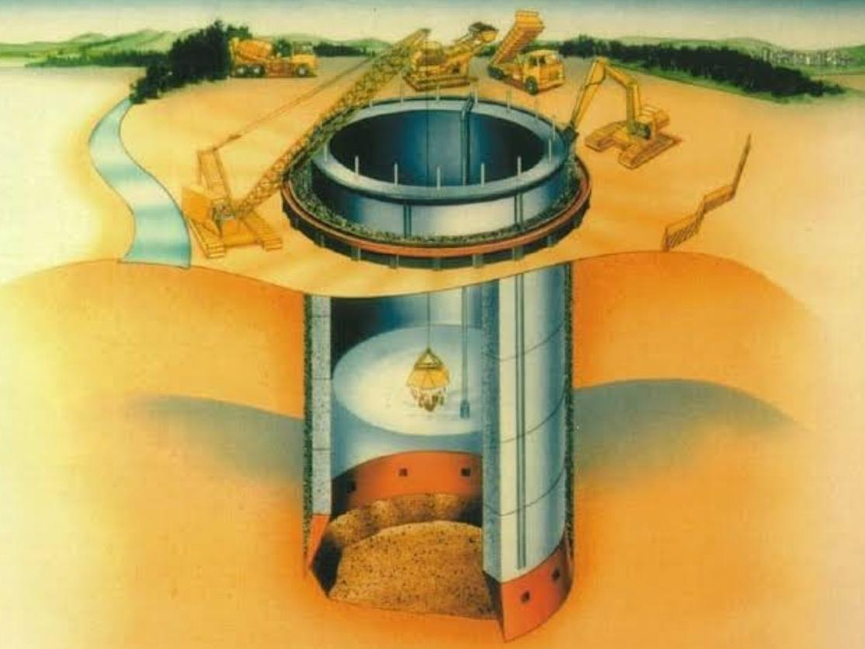

* + - It is generally used for foundations under water such as bridges.
    - It is not a solid structure like that of a pier but hollow inside resembling a well.
    - The load is transferred through the wall around it called staining.
    - It is a precast type.
    - It is gradually driven down by digging the soil from inside.
    - The bottom is plugged with concrete and the hollow portion is filled with sand.
    - The whole well is covered with a cap above which the superstructure will be constructed.

### Load bearing and framed structures

## LOAD BEARING STRUCTURES

## 

* In a load bearing structure, the walls of the building carry the loads from the floors and roof.
* Then these loads are transmitted by walls to the foundation. These load bearing walls are usually built in masonry, but may be of reinforced concrete too.
* Ordinary residential buildings up two floors usually adopt this method.
* Load bearing structures have limitations to resist earthquakes. Walls are thicker and carpet area available may be less.
* Room dimensions cannot be changed as walls have to be above walls only. In load bearing structure the walls carry loads apart from providing privacy and security.
* In load bearing structural systems external and internal walls serve as a structural element as well as serve the purpose of enclosure for protection from weather i.e. rain, sound, heat, fire etc.

## FRAMED STRUCTURES

## 

* In a framed structure, a framework or ‘skeleton’ of beams and columns is used to carry the structural loads down the building to the foundations.
* The framework is usually of steel or reinforced concrete, but in very small structures may be of timber or aluminum.
* Framed structures are more resistant to earthquakes. Walls are thinner and carpet area available may be more.
* Room dimensions can be altered.
* Here the walls are for privacy and security.
* No limitations exist in the form of taking walls and rooms over rooms.
* In framed structural systems, external and internal walls serve only the purpose of enclosures for creation of rooms and protection from weather.
* In framed structures, large span areas are possible. No limitations of span that is, room sizes.
* Large openings in walls are possible.

BRICK MASONRY

* The systematic arrangement of laying bricks and bonding them with mortar to form a unified mass which can transmit the super imposed loads without failure is known as brick masonry.
* It is mainly used in the construction of : Foundation Walls, Retaining walls, Columns, etc
* **TERMS AND DEFINITIONS**

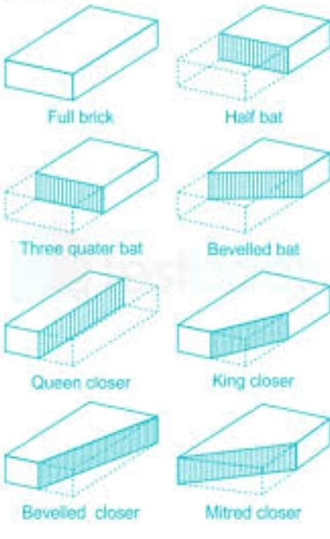

* + **Header**: Brick laid with its length perpendicular to the direction of the wall is known as a header.
  + **Stretcher**: Brick laid with its length parallel to the direction of the wall is known as a stretcher.
  + **Bat**: A portion of the brick cut across the width of the brick is known as bat. Bat is of two types:
    - **Three quarter bat:** where the length of the brick bat is three fourth times the length of the brick
    - **Half bat**: where the length of the brick bat is half times the length of the brick
  + **Closer**: Portion of the brick cut longitudinally with one long face uncut is known as closer. They are generally of four types:
    - **Queen closer:** half brick cut longitudinally
    - **King closer**:
      * obtained by cutting a triangular portion between the center of one end of the width portion and the center of the other end of the length portion.
      * In king closer, the width of one of its end is half that of full brick while width at the other end is equal to full width
    - **Beveled closer:** obtained by cutting a triangular portion of half width but of full length
    - **Mitred closer**:
      * obtained by cutting a triangular portion of brick through its width making an angle of 45-60° with the length.
  + **Quoin** : The external corner block of the wall
    - **Quoin Brick** : The brick which forms external corner of wall
    - **Quoin Header :** A quoin Header in the face of the wall which is a stretcher in the side wall
    - **Quoin Stretcher** : A quoin Stretcher in the face of the wall which is a Header in the side wall

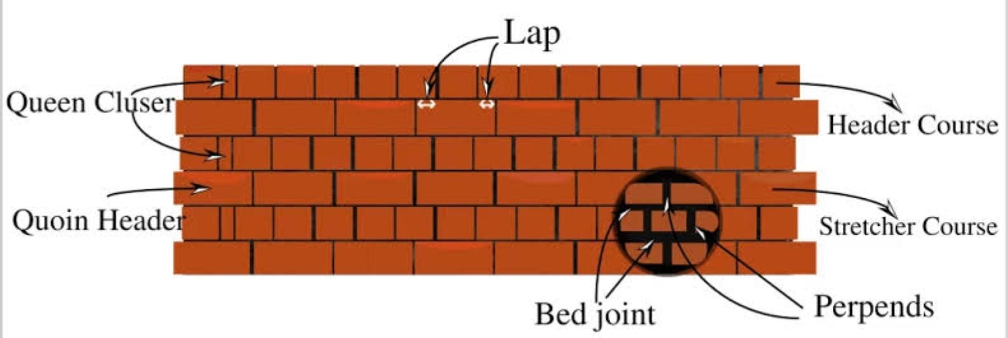

* + **Perpends**: Perpends are vertical joints separating the bricks in either length or cross direction
  + **Lap:** The horizontal distance between the vertical joints of successive courses of bricks is known as lap.
  + **Course**: A complete layer of bricks laid on the same bed is known as course.
  + **Frog:** Depression provided on the face of a brick to
    - provide a place for putting the impression of trademark/ year of manufacture of the brick
    - form a key of mortar in between any two adjacent courses to increase lateral strength of structure
    - to reduce weight of bricks to increase ease of convenience of laying bricks

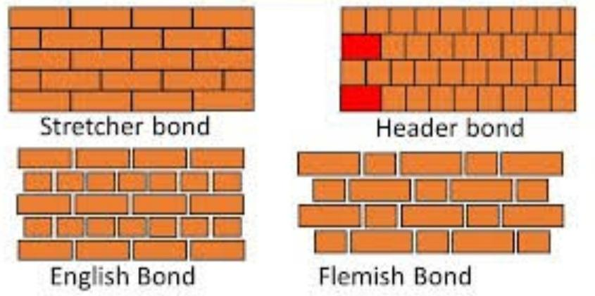

### Header bond

### 

* In header bond, all bricks are laid as headers on the faces of the wall i.e the width of the brick is along the direction of the wall.
* In header bonds, three quarter bats are used in alternate courses to stage the vertical joints.
* It is made when the thickness of the wall is equal to one brick and mainly used for partition walls, curved brickworks etc.

### Stretcher bond

### 

* In stretcher bond, all the bricks are laid as Stretchers on the faces of the wall i.e. The length of the brick is laid along the direction parallel to the direction of the wall.
* To stagger the vertical joints in the bond, headers are used. Stretcher bonds are mainly used in the construction of half brick thick partition walls.

### English Bond

* It is the most commonly used bond for all wall thickness. In English bond, alternate courses consist of headers and stretchers.
* To break the continuity of vertical joints, a queen closer is used just after the first header.

## TYPES OF ENGLISH BONDS

## 

## 1 ½ BRICK THICK WALL

## 

## 1 BRICK THICK WALL

## 

### Flemish bond

* In this type, Stretchers & headers are laid in the same course.
* A header in any course is centrally supported over a stretcher below it.
* For this, closers are inserted in alternate courses next to the first header for breaking the vertical joints in successive courses.

**1 BRICK THICK WALL**

### 

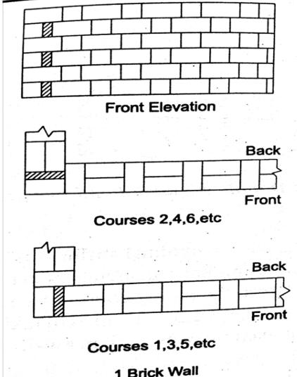

**1 ½ BRICK THICK WALL**

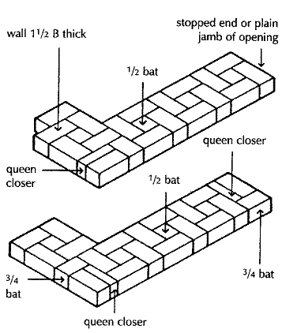

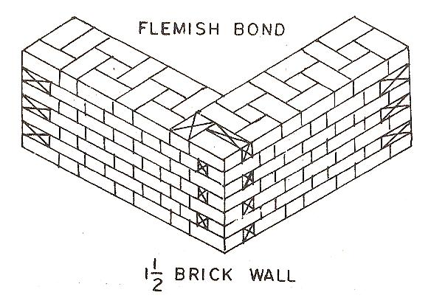

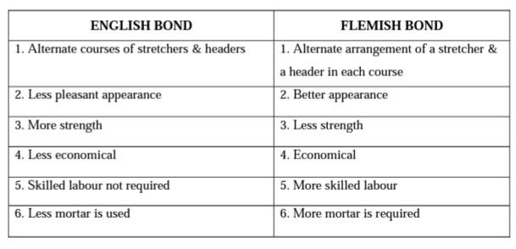

### Random Rubble Masonry

* In this type, stones of irregular shapes are used. But, they are arranged so as to give a good appearance.
* Thickness of mortar joints should be less than 12mm & face stones are chisel dressed.
* This type can be used for residential buildings, compound walls, etc.
* This can be further classified into
  + **Coursed Random Rubble Masonry:**

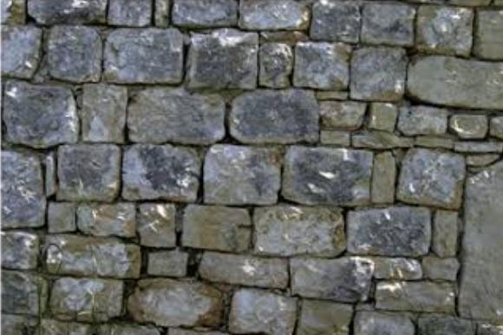

* + - In this, stones are laid to maintain level courses.
    - Hammer dressed stones are placed at regular intervals, known as cross stones.
    - Each header has a width not less than its height & projects into the wall at least three times its height.
  + **Uncoursed Random Rubble Masonry:**

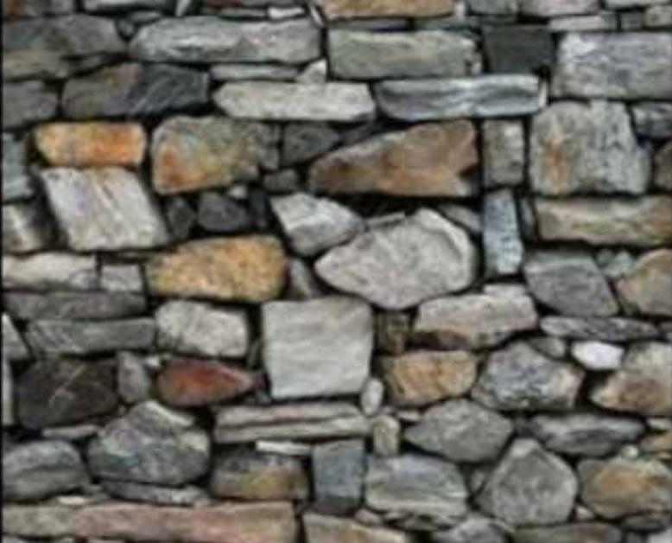

* + - This masonry is built without dressing.
    - The stones are of different shapes & mason selects the stones at random from heap & places them to form a strong bond.
    - Large stones are placed at corners to increase strength. This type affords a very rough appearance.

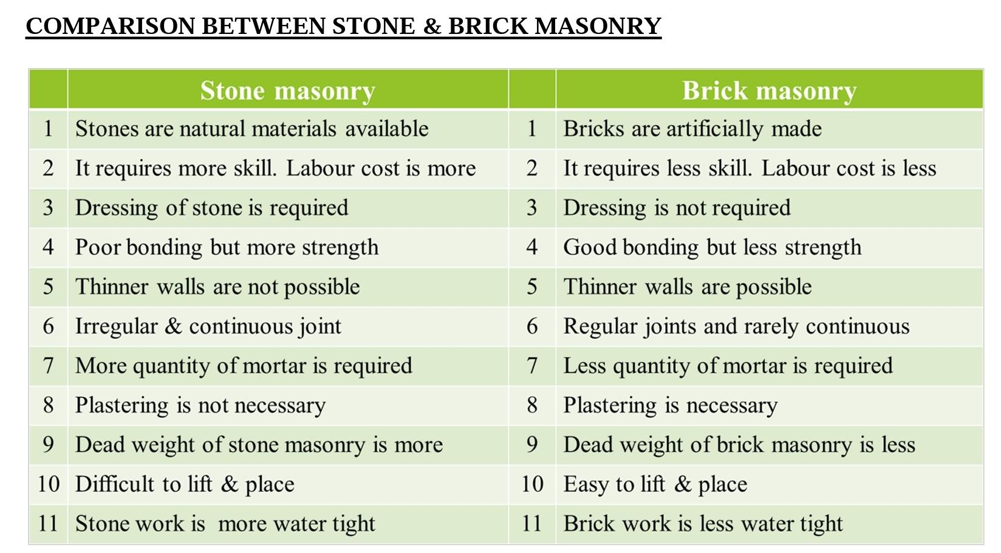

ROOFS AND FLOORS

# ROOFS

### Functions

* 1. Provides protection to persons and possession such as furniture, appliances, carpets etc
* 2. Protects from the effects of weather changes such as rain, snow, hail, high winds etc
* 3. Protects the exterior walls from water damage

### Types

* **FLAT ROOF**

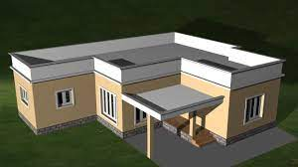

* + Flat roofs are roof without any slope greater than 10°.
  + They are usually provided in areas with less rainfall or have no snowfall.
  + In this type of roof, some amount of slope is provided on the surface to allow for the drainage of rainwater.
  + **Advantages** 
    - Construction and repair are simple Easier to make flat roof fire resistant
    - Construction of upper floor can be easily started Flat roof is more stable against high winds
    - Possess good insulating property
  + **Disadvantages**
    - Not suitable for high rainfall regions
    - Initial cost is high
    - Cracks may develop due to temperature variation
    - Proper surface slope need to be provided for drainage of rainwater
* **PITCHED/SLOPING ROOF**

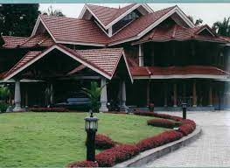

* + These roofs have sloping roof surfaces, the slope exceeds 10°.
  + They are suitable for places where rainfall or snowfall is heavy and also used in coastal regions.
  + Different slopes can be given depending upon the area covered, availability of materials, quantity of light and ventilation, available equipment etc.
  + **3 TYPES**

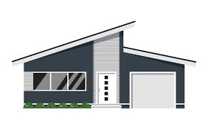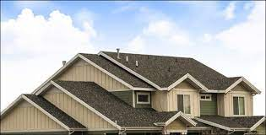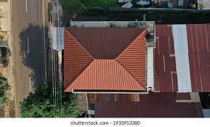

**SHED GABLE**

* + - **Shed roof/ Lean to roof:**
      * slopes in one direction only and can be used for covering verandah portions, extension etc.
    - **Gable roof:**
      * that slopes in two directions
    - **Hip roof**:
      * that slopes in four directions
  + **TERMS USED**
  + 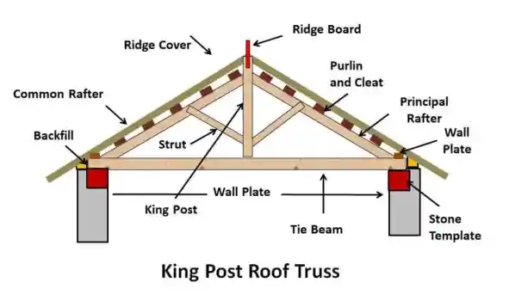
    - **Span**: It is the clear distance between the supports of the roof.
    - **Rise:** It is the vertical distance between the ridge and the wall plate.
    - **Pitch:** It is the slope of the roof obtained as the ratio of rise to span.
    - **Ridge**: It is the apex line of the sloping roof.
    - **Eaves**: The lower edge of the sloping roof is called eaves.
    - **Principal rafter:** It is the inclined member running from the ridge to the eaves.
    - **Wall plates:** They are long wooden members which are provided on the top of the brick wall for the purpose of fixing the feet of the principal rafter.
    - **Purlins**: They are horizontal members of wood or steel used to support roofing materials of a roof.
    - **Cleats:** These are short sections of wood or steel which are fixed on the principal rafters of trusses to support the purlins.
    - **Truss**: A roof truss is a framework usually of well formed triangles designed to support the roof covering or ceiling over rooms.
* **CURVED ROOF**

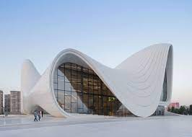

* + Roofs having their top surface curved in the form of shells and domes are known as curved roofs.
  + It is mainly suitable for public buildings and is mainly provided to have an architectural effect.

### Roofing materials

* Roof coverings are materials which give a protective surface to the roofing structure.
* Selection of the material depends upon the type of building, roofing structure provided, climate, cost etc.
* **TYPES OF COMMONLY USED ROOF COVERINGS**
  + **Mangalore Pattern Tiles**
  + 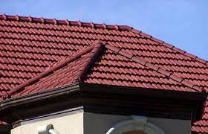
    - They have a flat pattern with suitable projections for interlocking with each other.
    - For covering 1sqm, 15 tiles are required.
    - Lifespan of these tiles is about 25years.
    - The main disadvantage of this type of tile is that it is heavier than other roofing materials.
  + **Asbestos Cement Sheets (AC Sheets)**
  + 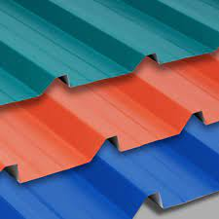
    - These are widely used sheets for industrial buildings, factories, sheds etc.
    - AC sheets are manufactured by mixing asbestos and Portland cement.
    - These sheets are available with corrugations and wider channels.
    - They do not require any protective paint or maintenance.
    - It is heavier than GI sheets.
    - It transfers heat and cold easily.
  + **Galvanized Iron Sheets (GI Sheets)**
  + 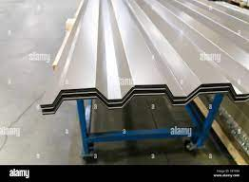
    - They are stronger than AC sheets but are costly.
    - GI sheets are galvanized with zinc to prevent rusting.
    - Mainly used in warehousing sheds, security cabins, garages etc.
    - These are waterproof and fire resistant.
    - These are light in weight and free from problems of cracking, warping and buckling.
  + 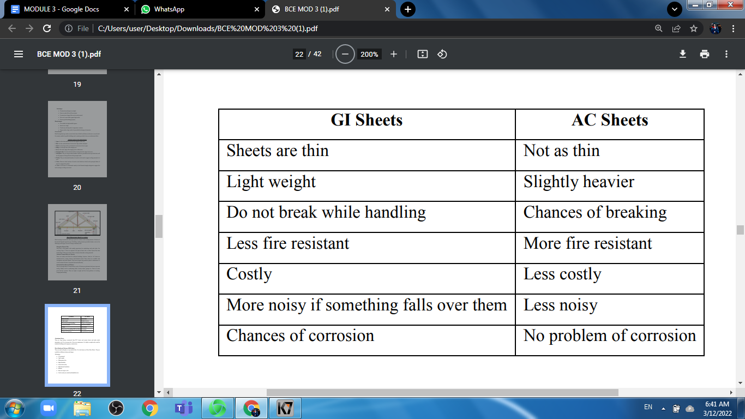
  + **Aluminum Sheets**
  + 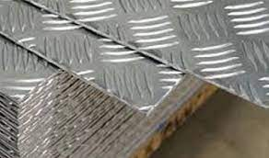
    - They are long lasting, economical than PVC sheets and cement sheets and make the inside atmosphere cool.
    - It is corrosion free.
    - It has zero maintenance.
    - It is light in weight and is used for industrial buildings and temporary constructions.
  + **Fiber Reinforced Polymer (FRP) Sheets**
  + 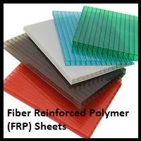
    - They are made with glass or any suitable fiber.
    - It is also known as Fibre Glass Sheets.
    - They are available in different colours and shapes.
    - **Advantages**
      * UV protected
      * Light weight
      * Maintenance free
      * High flexibility
      * Can be bent easily
      * High thermal insulation
      * Durable
      * Does not warp or wilt
      * Can be easily cut, tooled and handled at site
  + **PVC Corrugated Sheets**
  + 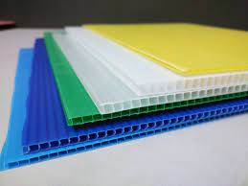
    - They are made of PVC plastic and other plastic and other plastic like polycarbonate.
    - These are available in different colors.
    - Compared to other roofing materials, they are lightweight, durable, fire resistant and rust free
  + **PVC Roof Membranes**
    - These roofs are highly resistant to puncture, impact, flame exposure etc.
    - It is durable and has temperature resistance.
    - It is user friendly and improves aesthetic appearance.
    - It also has the ability to resist heavy rainwater.

# FLOORS

* Floors are components of buildings which divide a building into different levels, one above the other for the purpose of creating more accommodation within a limited space.
* **COMPONENTS** 
  + **1. Sub Floor or Base Course**: It is the bottom most part of a floor which imparts strength and stability to support the floor. It is made of brick, stone, wood and concrete.
  + **2. Floor Covering or Flooring:** It is the covering over subfloor providing a clean, hard, smooth, impervious, durable and attractive surface to the floor. It is made of brick, stone, timber, tile, concrete, mosaic, marble, glass etc.

### Functions

* Provide a level surface that is strong to support the users and other components of the building
* Carry loads imposed on them
* Prevent dampness rising from the ground into the building
* Provide thermal insulation
* Prevent growth of plant life into the building
* Provide a suitable wearing surface

### Types

* **I. Based on the position of the floors:**
* 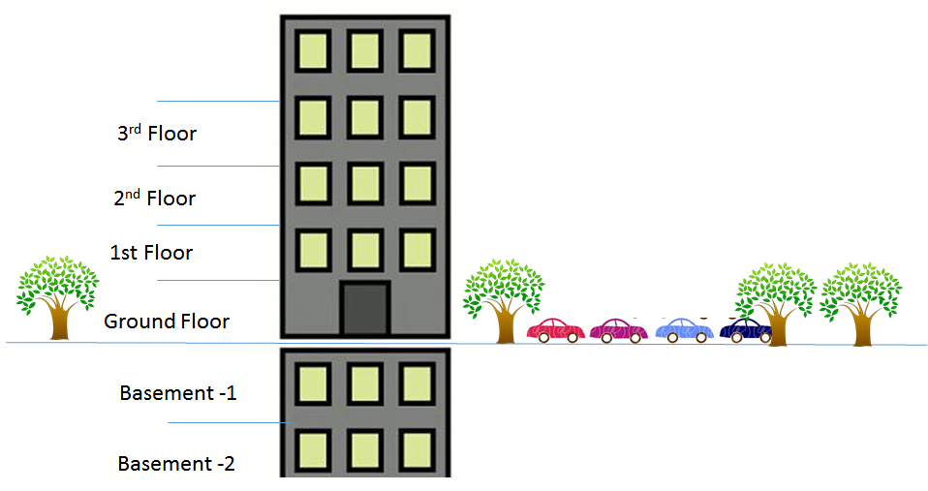
  + **a. Ground floor**:
    - floor constructed just above the ground level
  + **b. Basement floor:**
    - floor constructed below the ground level, that is in the basement
  + **c. Upper floors**:
    - floors above the ground floor
* **II.Based on the materials used:** 
  + **a. RCC Floor:**
  + 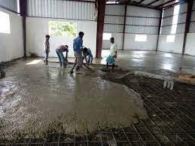
    - In this type of floors, steel bars and concrete is used to form floors.
    - Concrete slabs are used having thickness of 80-150mm and for larger spans of floors (i.e more than 4m) and for greater loads, beams and slabs construction is adopted.
    - The steel bars used are 9-12mm in diameter.
  + **b. Flat slab floor:**
  + 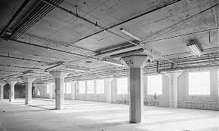
    - In this type of floor, the slab is built with the supporting columns only i.e. without any beams.
    - Hence the load on the slab is conveyed directly on to the column.
      * **Advantages:** 
        + Formwork is simple and economical
        + Construction is simple and easy
        + More economical for larger spans and heavy loads as even for heavy loads, thinner sections are enough

### Flooring Materials

* Floor coverings are provided to improve the appearance of the floors.
* It also imparts a clean, noiseless and damp proof surface to the subfloor.
* The following are some of the floor coverings or flooring materials commonly used
  + **Mosaic Floor Covering**
  + 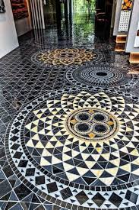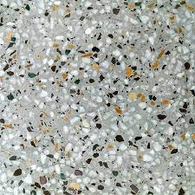
    - It consists of a base concrete and mosaic topping.
    - This type of floor is widely used in theaters, temples and superior type of buildings.
    - **Preparation:**
      * For construction of mosaic flooring, first a hard concrete base is laid.
      * Over this base, while still wet, a 2cm layer of cement mortar (1:2) is evenly laid.
      * Upon the bed of cement mortar, small pieces of broken tiles are arranged in definite patterns.
      * After this, cement or coloured cement is sprinkled at the top and the surface is rolled till an even surface is attained.
      * The surface is left for 24hrs to dry and then it is rubbed with pumice stone to get a smooth and polished surface.
      * The polished surface is allowed to dry for about 2 weeks before use.
  + **Mosaic Tile Flooring**
    - Mosaic tiles of different size and color combinations are now available in market.
    - This type of flooring is widely used in residential buildings, shops, theatres etc.
    - **Preparation:**
      * Over the concrete bedding, a cement mortar layer of 1:1 mix is spread and over that mosaic tiles are arranged.
      * A thin paste of cement is applied to their sides.
      * Tiles are then slightly tapped till the cement oozes out through the joints.
      * Oozed out cement is cleared with sawdust.
      * After 3 days, the joints are rubbed with carborundum stone and then by pumice stone.
      * Finally the surface is washed with a weak solution of soft soap in warm water
  + **Ceramic Tile Flooring**
  + 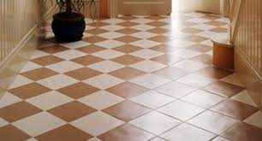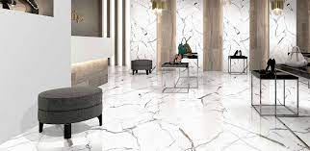
    - While selecting floor covering materials that requires water proofing i.e. flooring in wet areas like bathrooms and kitchen, ceramic tile is the best choice.
    - It can also be used as floor tiles, indoors or as counter tops.
    - They are of different colour, size and quality.
    - Finishes are available as matte, glazed, textured for anti-slip etc.
    - One of its biggest drawbacks is that the grout lines could be very hard and difficult to clean
  + **Marble Flooring**
  + 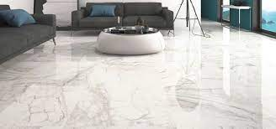
    - It is one of the expensive products in floor coverings.
    - It is mainly utilized in the dining area, pathways and balconies.
    - They are available in slabs, blocks and tiles usually in size of 12” x 12” and is available in colours of green, black and white.
    - They are durable, can last for years, can be easily cleaned and maintained and are also easy to install.
    - **Preparation**:
      * Over the concrete bedding, 20cm cement mortar layer of 1:2 mix is spread under each individual slabs.
      * The marble is then laid over the mortar.
      * Gently pressed with wooden mallet and leveled.
      * The marble is then again lifted up and fresh mortar is added to the hollows of the bedding mortar.
      * The mortar is allowed to harden slightly; cement mortar is again spread over it.
      * The edges of the already laid slabs are smeared with cement slurry paste and then the slab is placed in position.
      * It is gently pushed with wooden mallet so that cement oozes out.
      * It is cleaned with sponge.
      * The paved area is cured for 7 days.
  + **Tiled Floor Covering**
  + 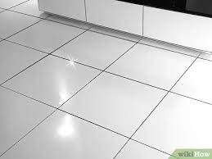
    - Clay tiles of different sizes, shapes, thickness and color available in the market.
    - **Preparation:**
      * Over the concrete bedding after 2-3 days, a cement mortar layer of 1:1 mix is spread.
      * The tile is then laid over the mortar.
      * Thin paste of cement is applied to their sides.
      * The tiles are then gently tapped till the cement oozes out through the joints.
      * The oozed out cement is cleaned.
      * After 2-3 days, the surface is washed with weak solution of soft soap in warm water
  + **Concrete Flooring**
  + 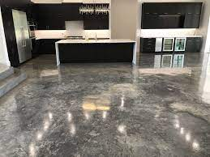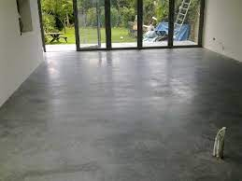
    - This kind of floor is mainly favored by the industries. It provides more strength to the floors compared to other flooring types.
  + **Granite Flooring**
  + 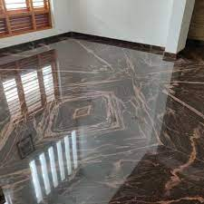
    - Granite is a common flooring material for public spaces and high class buildings such as offices, shopping malls, hotels etc.
    - It is available in the form of tiles and slabs of various sizes in market
  + **Synthetic Flooring**
  + 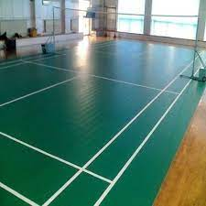
    - Synthetic materials like epoxies and polyesters are used in flooring, thereby replacing the use of cement.
    - Hence it reduces the self weight of flooring.
    - For the preparation of the floor, synthetic material and marble chips are mixed with water to get a plastic paste.
    - This mixture is then laid on the rough base already prepared.
    - Grinding and polishing are performed after 16-48hours.
    - They produce superior flooring with properties of abrasion, resistance to chemical attack, weather resistant etc.

BASIC INFRASTRUCTURE SERVICES

* Infrastructure refers to the fundamental facilities and systems serving a country, city or area including the services and facilities necessary for its economic development.
* So it can be defined as “the physical components of interrelated systems providing commodities and services essential to enable, sustain or enhance societal living conditions”.
* Infrastructural services typically includes: roads, bridges, tunnels, water supply, sewers, electrical grids, telecommunications etc.

### MEP

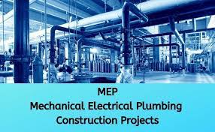

* Mechanical, electrical and plumbing (MEP) refers to these aspects of building design construction.
* MEP design is important for planning, decision making, accurate documentation, performance, cost estimation, construction, and operating/maintaining the resulting facilities.
* **SYSTEMS IN MEP**
  + **MECHANICAL**
    - Mechanical systems most commonly relate to heating ventilation and air conditioning (HVAC) systems, but they can also relate to transportation systems such as elevators and escalators, elements of infrastructure, industrial plant and machinery, and so on.
    - Heating ventilation and air conditioning can be used in buildings to: -
      * Regulate internal temperatures
      * Regulate internal humidity
  + **ELECTRICAL**
    - Electrical systems might include: -
      * Control systems
      * Power supply and distribution
      * Interior and exterior lighting
      * Information and telecommunications systems
      * Security and access systems
      * Detection and alarm systems
  + **PLUMBING**
    - Plumbing refers to any system that allows the movement of fluids typically involving pipes, valves, plumbing fixtures, sanitary fixtures tanks and other apparatus.
    - Plumbing systems might be used for; -
      * Potable cold and hot water supply -
      * Water recovery and treatment systems -
      * Rain water, surface and subsurface water drainage -
      * Heating and cooling -
      * Waste removal -
      * Fuel gas piping

### HVAC

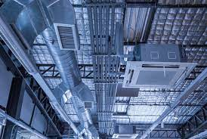

* HVAC systems are heating, ventilation, and air conditioning systems.
* This is the system or combination of systems used to provide a comfortable temperature in buildings and maintain high levels of air quality.
* The objective of an HVAC system is to ensure that the indoor environment is both safe and comfortable for humans.
* Safety here mainly concerns with the indoor air quality or IAQ, indoor air quality demands indoor air should have enough oxygen and be free of noxious gasses.
* Heating is the process of generating heat (i.e.; warmth) for the building.
* This can be done via central heating with a boiler, furnace, or heat pump to heat water, steam, or air in a central location such as a furnace room in a home .
* The heat can be transferred by convection, conduction, and radiation.
* Pipes are used to transport heat to the rooms with heated water or steam.
* Most modern hot water boiler heating systems have a circulator, which is a pump, to move hot water through the distribution system.
* The heat can be transferred to the surrounding air using radiators, hot water coils or other heat exchangers.
* The radiators are mounted on walls or installed within the floor to produce floor heat
* The use of water as the heat transfer medium is known as hydronics
* Ventilation is the process of exchanging or replacing air in any space to provide high indoor air quality.
* This involves temperature control, oxygen replenishment, and removal moisture, odours, smoke, and dust, air born bacteria, carbon-dioxide, and other gases.
* Ventilation removes unpleasant smells and excessive moisture, introduces outside air, keeps interior building air circulating, and prevents stagnation of the interior air.
* **METHODS OF VENTILATING A BUILDING**
  + **A) Mechanical, forced, ventilation**
    - Itis provided by air handler units (AHU) and used to control indoor air quality, excess humidity, odours; contaminants.
    - Kitchens and bathrooms have typically had mechanical exhausts to control odours and humidity.
  + **B) Natural ventilation**
    - It is the ventilation of a building with outside air without using fans or other mechanical system.
    - It can be via operable windows, louvers, when spaces are small.
    - Natural ventilation schemes use very less energy.
    - But in warm or humid climate, maintaining thermal comfort solely via natural ventilation may not be possible.
* **Air conditioning**
  + It is the process of treating air so as to control simultaneously its temperature, humidity, purity, distribution, air movement and pressure to meet the requirements of the conditioned space such as comfort and health of human beings, needs of industrial processes and other need in the building
  + **Purposes of Air Conditioning**
    - a) It is required to preserve and maintain the health, comfort and convenience of the occupants in the residential buildings.
    - b) It is required to preserve the quality of the products and to maintain the working of industrial processes such as artificial silk and cotton cloth etc
    - c) In the commercial buildings like theaters, offices, shops, banks, restaurants, stores, etc air conditioning is required to improve the working atmosphere and maintain comfort within these concerns.
* **CLASSIFICATION OF HVAC SYSTEMS**
  + The major classification of HVAC systems based on location of primary equipment
    - **Central system:** In which the primary equipment location to be centralized as conditioning entire building as a whole unit
    - **Decentralised or local system:** In which equipment separately conditioning a specific zone as part of the building

### Elevators

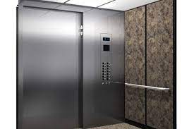

* An elevator is a type of vertical transport equipment that efficiently moves people or goods between floors, levels, decks of building or other structures.
* Elevators are generally powered by electric motors that derive the traction cables up and down.
* **KEY PARTS OF ELEVATORS**
* 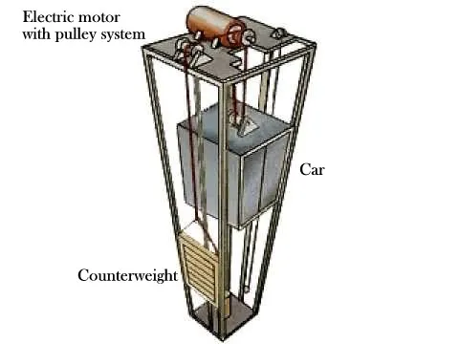
  + One or more cars or metal boxes carrying and goods that rises up and down Counterweights that balances the cars
  + Electric motors that hoists the cars up and down with a braking system.
  + A system of strong metal cables and pulleys running between the cars and motors
  + Various safety systems to protect the passengers if a cable breaks
* In large buildings, an electronic control system is equipped that direct the cars to correct floors and to ensure the quickest and efficient performance of the elevator.
* **TYPES OF ELEVATORS**
  + **1. Passenger Elevator:**
  + 
    - They are used to carry passengers from one floor to another. They are commonly used in hospitals, high rise buildings etc.
  + **2. Freight Elevators:**
  + 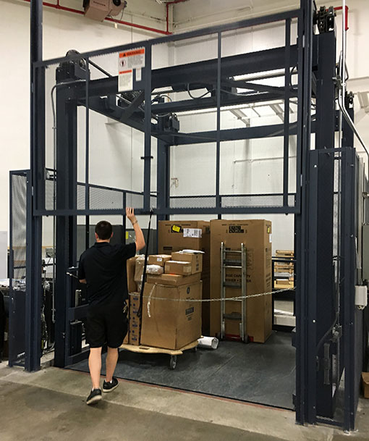
    - It is also known as goods.
    - Lift designed to carry goods rather than passengers.
    - They are typically larger and capable of carrying heavier loads generally from 2300-4500 kg.
    - They usually have manually operated doors and often have rugged interior finishes to prevent damage while loading and unloading
  + **3. Vehicle Elevators**:
  + 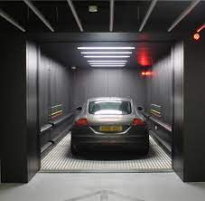
    - They are used within buildings or areas with limited space typically to move cars into parking garage or manufacturer’s storage.
    - Most vehicle elevators have a weight capacity 2 tons.
  + **4. Boat Lift:**
  + 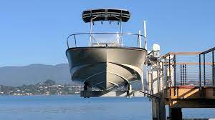
    - In some smaller canals, boat and small ships can pass between different levels of a canal with a boat elevator
  + **5.Aircraft Elevators:**
  + 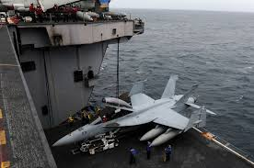
    - They carry aircraft between the flight deck and hangar deck for operations or repairs.
    - They are designed for a much higher capacity up to 91000kg.
  + **6. Limited Use and Limited Application elevators (LU/LA):**
  + 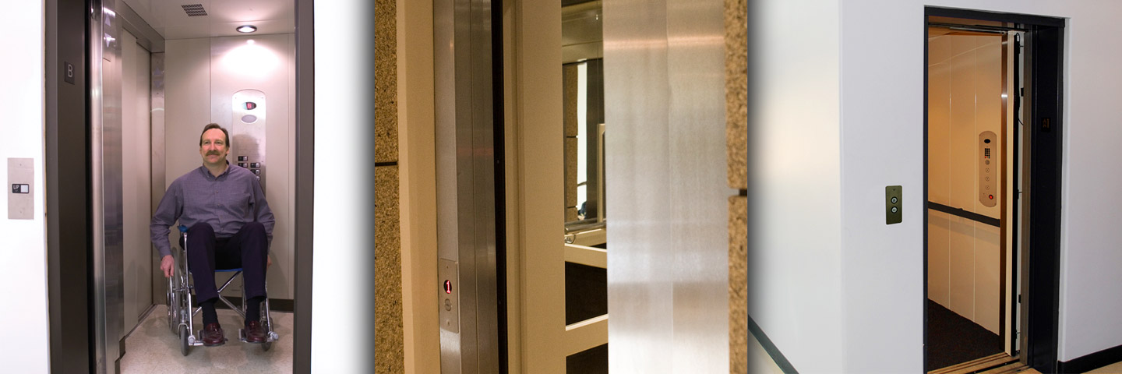
    - It is a special purpose passenger elevator primarily meant to be handicapped accessible and there might only be room for a single wheelchair and a standing passenger.
  + **7. Residential Elevator:**
  + 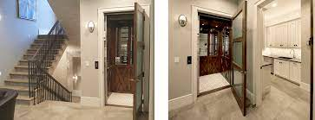
    - It is often permitted to be of lower cost and complexity.
    - They have unique design characteristics suited for home furnishings.
    - Construction may be less robust with shorter maintenance periods but safety systems must be still present.
  + **8. Dumb water:**
  + 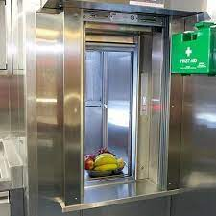
    - They are small freight elevators intended to carry food.
    - They often provided in hotels to link kitchen with rooms on other floors.
  + **9. Scissor Lift:**
  + 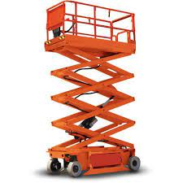
    - They are usually mobile work platforms that can be easily moved to where they are needed.
    - The mechanism that makes them go up and down is like that of a scissor jack

### Escalators

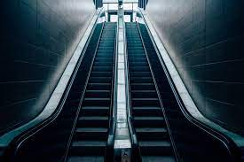

* An escalator is a conveyor type transport device that moves people.
* It is a moving staircase with steps that move up or down using a conveyor belt and tracks keeping each step horizontal for the passengers.
* They are used to connect airport terminals, packing garages, sport facilities, shopping malls, convention centers etc.
* They are used in straight sections but spiral escalators are also available
* **General Specifications** 
  + **Speed:** 0.46-0.5m/s
  + **Angle of inclination**: 30-35º
  + **Width:** Normally width are 61cm, 91.4cm and 1.22m
  + **Design:** Design of escalator is carried out with a handling capacity for 3200-6400 persons/hour
* **ADVANTAGES**
  + **1.Moving People:**
    - It can move large numbers of people at once from one area to another.
    - People can move both upward and downward when a pair of escalators is deployed next to each other.
  + **2. Comfort:**
    - An escalator transports people automatically when switched on with individuals simply standing still.
    - Traveling on an escalator thus requires less physical extortion.
    - Rendering more comfortable conditions to the individuals.
  + **3. Efficiency:**
    - It allows individuals to move between many floors of a building in a relatively short amount of time, thereby reducing the need for waiting periods as in case of elevators
  + **4. Guidance:**
    - Escalators are effective when used as a mean of guidance and circulation especially in a city subway hub etc.
  + **5.Adjustable Speed**:
    - The escalator offers an advantage to building managers in that its speed can be adjusted.
    - It can also save energy during quiet periods since they can be turned off, essentially becoming a staircase

### Ramps

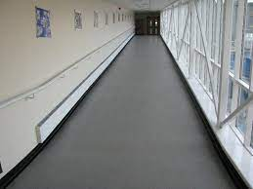

* Ramp is an inclined plane joining two floors and is mainly used for carrying machinery, equipments, trolleys, cars etc to upper floors in multistoried and public buildings.
* Ramps are either located externally i.e. extending from general building line or inside the building.
* In case of movement of heavy loads, it is preferable to provide the ramps externally whereas for pedestrians it is preferable to provide ramps inside the building.
* The dimensions of the ramp also depend upon its use.
* For pedestrian traffic, a minimum slope of 1 in 10 and a maximum slope of 1 in 8 can be adopted.
* Its width is limited to 2m.
* Landing at every change in direction are provided with width equal to that of the ramp.
* Hand rails are to be provided on both sides of the ramp.
* The ramp need not be straight for the whole distance.
* It can be curved, zigzag and spiral.
* For carrying cars and other machinery, much greater dimensions are required.
* Normally ramps are designed as inclined RCC slabs supported on columns.
* Floors are surfaced with non slippery materials or transverse grooves to be provided on surface for providing sufficient friction.
* **TYPES OF RAMPS**
  + **1. Inside Ramps**
  + 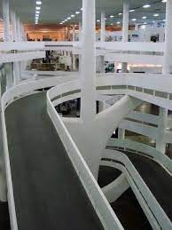
    - A ramp provided inside a building more than three storey’s high or a building of non combustible construction as a means of way out is known as inside ramps.
    - It should be of non combustible construction and also be protected by separation from other parts of the building.
    - They should also have vertical protective barriers along the edges of the ramps and along the edges of the floor opening over the ramps to prevent falls over the open edges.
  + **2. Outside Ramps**
  + 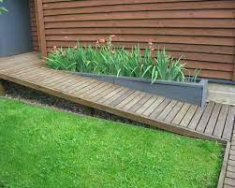
    - A ramp permanently installed on the outside of a building as an acceptable means of way out is known as outside ramps.
    - For outside ramps more than 3 storeys, guards along the ramp edges should be atleast 1.2m.
  + **3. Powered Ramps**
  + 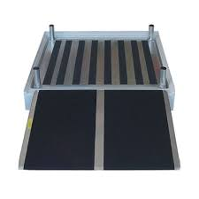
    - In some building such as air terminals, in which pedestrians have to be moved speedily over long distance, they are transported on a moving walk called powered ramps, a type of passenger carrying powered device on which passengers stand or walk provided at a slope of 1 in 15.

### Fire Safety Buildings

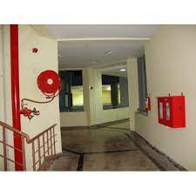

* The primary goal of fire safety efforts is to protect building occupants from injury and to prevent loss of life and prevent property damage.
* According to Indian law, minimal fire safety equipment is mandatory for any developed property.
* These laws are given by national building code (NBC), which is a document containing standardized requirement for the design and construction of most types of building in the country.
* NBC stipulates certain norms and regulations in the construction of buildings to ensure fire safety.
* **IMPORTANT ASPECTS**
  + 1. According to the height of the building, there shall be sufficient fire way around the building with a minimum width of say, 5m etc… for the entry of fire engines.
  + 2. There shall be alternate fire stairs and lifts apart from the common stairs and lifts depending upon the floor area of the building.
  + 3. Non-combustible materials should be used for construction of buildings and the internal walls of staircase enclosures should be of brick work or reinforced concrete or any other material of construction with minimum of 120 min rating.
  + 4. Emergency power supplying distribution system for critical requirement for functioning of fire and life safety system particularly for the operation of fire pumps, lifts, emergency exit lighting, signage lighting, fire alarm system, public address system and for fire control room.
  + 5. Sufficient exclusive storage of water at ground water tank and at terrace with capacity depends on floor area of building.
  + 6. Landings of fire stair shall abut with external wall and openings shall be closed with breakable glass.
  + 7. Sufficient space shall be kept free at terrace for rescue operations and helipads are mandatory for high rise buildings
* **FIRE EXTINGUISHING SYSTEMS/INSTALLATIONS**
  + Portable firefighting equipment like fire extinguishers as well as mobile firefighting equipment like fire tenders and other vehicle mounted fire fighting appliances can be used for tacking fires whether inside a building or in the open land.
  + On the other hand, for tacking fires particularly inside buildings structures or in specific areas, fire extinguishing systems installed permanently within the premises will be required for providing adequate fire protection.
  + These fixed fire extinguishing systems/installations can be based on various extinguishing media used for protection, as stated below Local bodies and development authorities approve buildings based on a NOC issued from fire and rescue department.
  + For obtaining NOC, the above installations of fire fighting equipments and other regulations in building constructions are to be compiled.

GREEN BUILDINGS

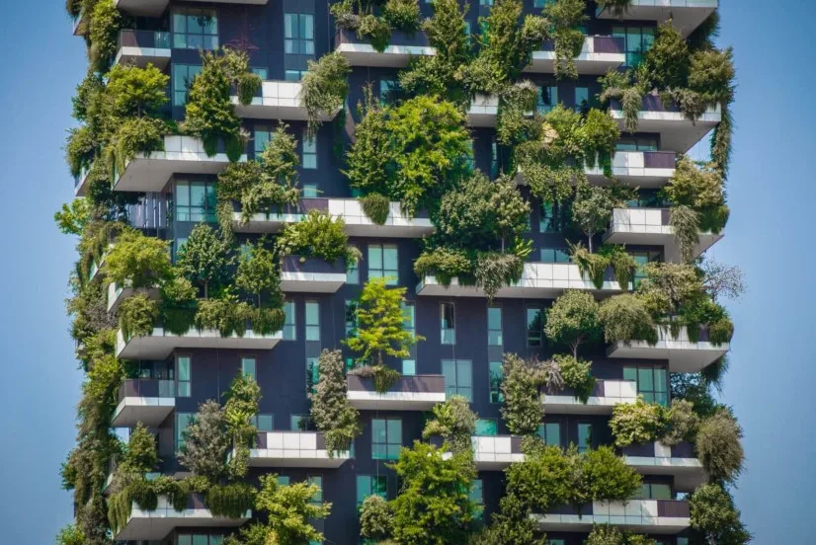

* Global warming leads to changes in climate, changes in rainfall pattern, rise of sea level, acid rain, ozone layer depletion etc.
* On realizing the environmental responsibilities, many efforts were put forth and one such intelligent initiative is the concept of “Green Buildings”.
* Green buildings have a new approach to save water, energy and material resources in the construction and maintenance of buildings and can reduce or eliminate the adverse impact of buildings on the environment and occupants.
* “A green building is on which uses less water, optimizes energy efficiency, conserves natural resources, generates less waste and provides healthier spaces for occupants as compared to a conventional building”
* Green buildings are eco friendly structures.
* This helps the earth and people to retain nature to a maximum extent possible in three ways with reference to the location of buildings as below.
  + 1. Retain the external environment at the location of the building.
  + 2. Improve internal environment for the inhabitants.
  + 3. Preserve the environment at places far away from the building

### Green Building Materials

* The basic concept behind materials used in the construction of green building is the minimum release of greenhouse gases (CO2) during the production of those materials.
* Also these materials consume minimum quantities of water, energy and raw materials during production and conveyance.
* Many of these are made by reuse and recycle methods.
* Green building materials are reusable, energy efficient, sustainable and environment friendly.
* Some of the green building materials are described in following sections.
  + **1. Earthen Materials**
  + 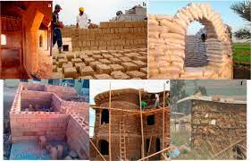
    - Earthen materials like adobe, cob and rammed earth are being used for construction purposes.
    - For good strength and durability – chopped straw, grass and other fibrous materials etc. are added to earth.
    - Even today, structures built with adobe and cob can be seen in some remote areas.
  + **2. Engineered Wood**
  + 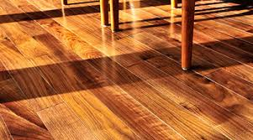
    - Wood is one of the most famous materials used around the world.
    - But in the process of conversion of raw timber to wood boards and planks, a considerable quantity of wood gets wasted.
    - This wastage can also be used to make structural parts like walls, boards, doors etc. in the form of engineered wood.
    - Engineered wood contains different layers of wood, usually the middle layers are made of wood scraps, softwoods, wood fibers etc.
  + **3. Structural Insulated Panels (SIPs)**
  + 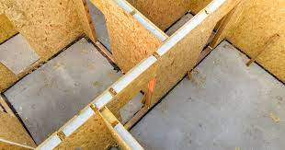
    - Structural insulated panels (SIPs) consist of two sheets of oriented strand boards or flake board with a foam layer between them.
    - They are available in larger sizes and are used as walls and partitions for the structure.
    - Because of size, they often need heavy equipment to install, however, they provide good insulation.
  + **4. Insulated Concrete Forms**
  + 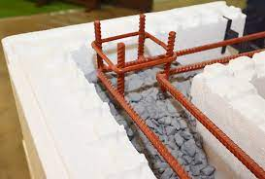
    - Insulated concrete forms contain two insulation layers with some space in between.
    - This space contains some arrangement for holding reinforcement bars.
    - After these forms are placed at site with reinforcement, concrete is poured into this space.
    - This will act as a wall or partition or any other structure.
    - They are light in weight, fire resistant, low dense and have good thermal and sound insulation properties
  + **5. Cordwood**
  + 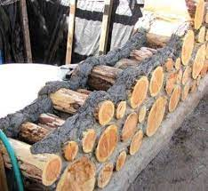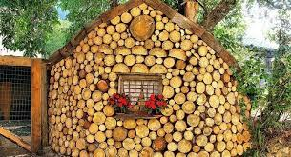
    - If wood is abundantly available at the site of construction, cordwood construction is recommended.
    - It requires short and round pieces of wood which are laid one above the other, width wise and are bonded by a special mortar mix.
    - They are strong, environmentally friendly and also give a good appearance to the structure.
  + **6. Cellulose**
  + 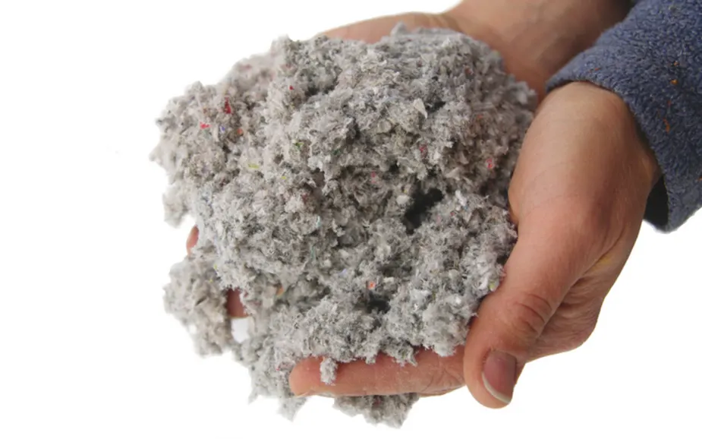
    - Cellulose is a recycled product of paper waste and it is widely used around the world for insulation purposes in buildings.
    - It acts as a good sound insulator and available for cheap prices in the market.
  + **7. Polyurethane**
  + 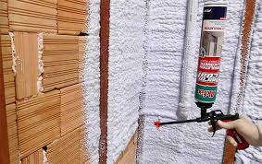
    - Polyurethane foam is available in the form of spray bottles.
    - They are directly sprayed onto the wall surfaces or to where the insulation is required.
    - After spraying it expands and forms a thick layer which hardens later on.
    - They offer excellent insulation and prevent leakage of air.
  + **8. Fiberglass**
  + 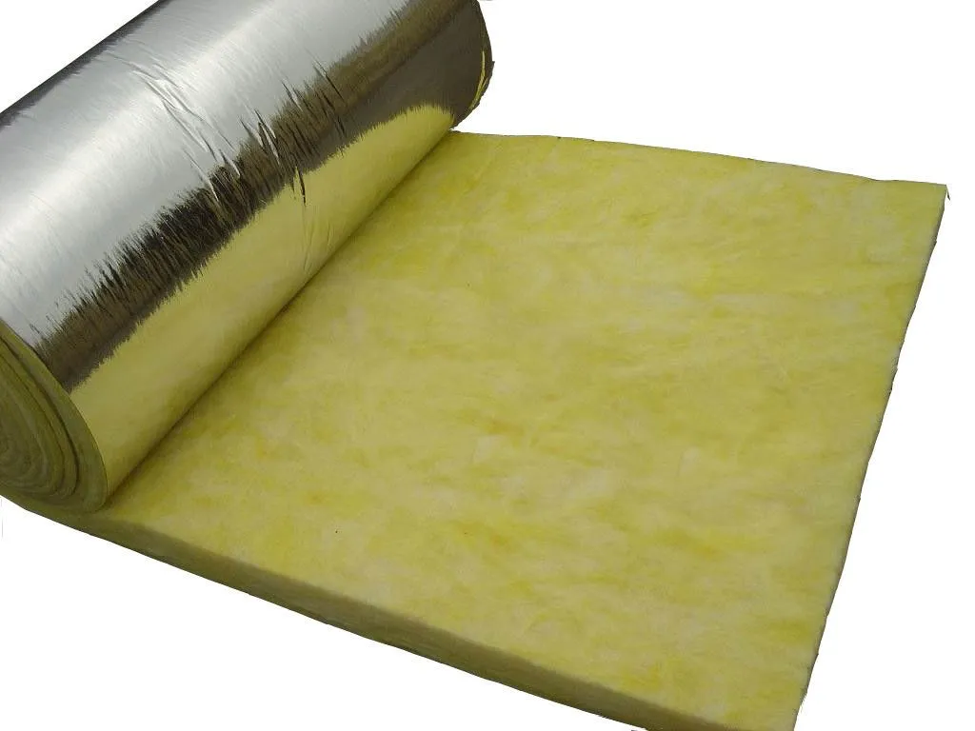
    - Fiberglass is also used for insulation purposes in the form of fiberglass batts.
    - Even though it contains some toxic agents, because of its super insulation property at low cost it is considered as a green building material.
  + **9. Natural Fiber**
  + 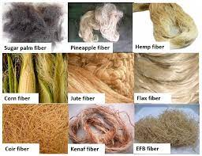
    - Natural fiber like wool, cotton can also be used as insulation materials.
    - Recycled cotton fibers or wool fibers are converted into a batt and installed in wooden frame sections.
  + **10. Non-VOC paints**
  + 
    - Non-VOC paint or green paint is recommended over VOC containing paints.
    - Presence of volatile organic compounds (VOC) in paint reacts with sunlight and nitrogen oxide resulting in the formation of ozone which can cause severe health problems for occupants.
  + **11. Timbercrete**
  + 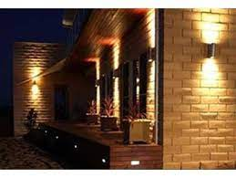
    - Timbercrete is a combination between timber waste from various sources and concrete- a green material that is lighter than the solid concrete with greater strength and insulating capabilities.
    - This green material provides unique thermal qualities that combine thermal mass and insulation to make it suitable for eco-housing.
    - Timbercrete is also bushfire proof, which allows minimal heat transfer and radiation.
    - The other benefit is that this material is very user-friendly.
  + **12. Straw Bale**
  + 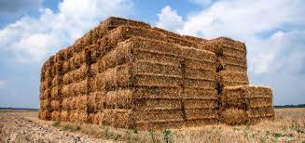
    - Straw bale is another green building material which can be used as framing material because of good insulation properties.
    - They also act as soundproof materials.
    - Straw bale can be used as fill material in non load bearing walls between columns and, in beams framework.
    - Since air cannot pass through them, straw bales also have some resistance to fire.
  + **13. Ferrock**
  + 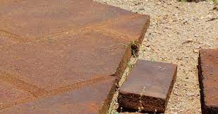
    - Ferrock is a new material that uses recycled materials including steel dust from the steel industry to create a concrete-like building material.
    - It is stronger than concrete.
    - This unique material actually absorbs and traps carbon dioxide as a part of its drying and hardening process.
    - Hence it is not only less CO2 intensive than traditional concrete, but actually carbon neutral.
  + **14. Stones Slate/Stone-**
  + 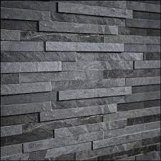
    - These natural materials are excellent green choices but are very expensive due to both material and labor considerations but can be cheap at places where they are easily available.
    - They have very long life.
  + **15. Fiber cement**
  + 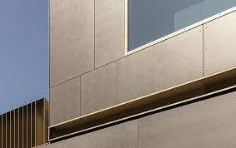
    - This material is made from wood, sand and Portland cement.
    - Fiber cement offers excellent durability and fire resistance and is less expensive than many common wood choices.

### Energy Management Systems

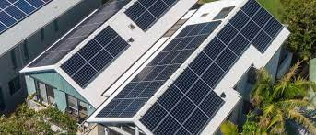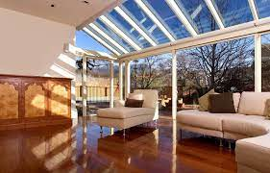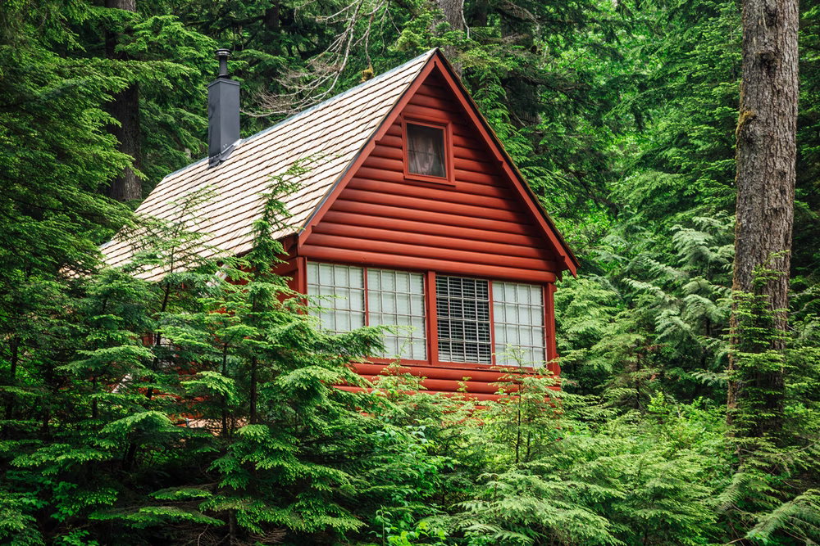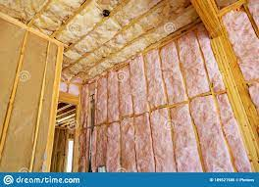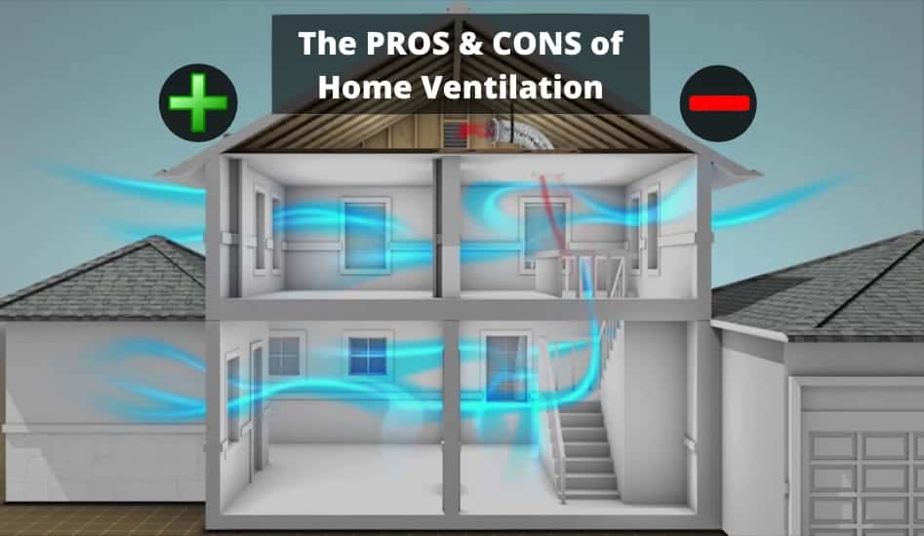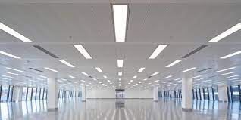

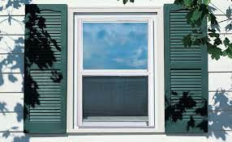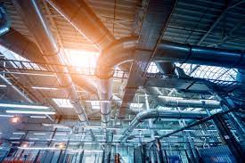

* In the modern world, 30-40 percent of energy is consumed by buildings. It is predicted that this may increase up to 48 percent by 2025.
* This warrants green buildings to achieve energy efficiency.
* There are many methods to improve buildings' energy efficiency.
  + 1) The solar system on a green building is trapped to supplement conventional energy. Use of photo voltaic cells convert solar energy.
  + 2) The natural light is allowed to enter in the intermediate floors to minimize the usage of electricity.
  + 3) Sunlight is restricted by the high grown trees outside the lower floors of the building.
  + 4) High efficiency light fixtures like LED lamps make a pleasant lighting apart from saving the energy.
  + 5) Installation of motion detectors for lighting control which makes light to glow only when area is occupied.
  + 6) High efficiency windows and insulation in walls, ceilings, and floors are used for the benefit of better temperature control.
  + 7) The HVAC system must have a correctly designed distribution system to minimize the amount of airflow necessary to heat and cool the building.
  + 8) New innovation in insulation can reduce the energy used in manufacturing insulation and allow insulation to be recycled or biodegradable. Minerals, fibrous and cellulose derived materials are now available for insulation purposes.
  + 9) Weather stripping, maintaining entry door closers and installing storm windows reduces the energy demand.
  + 10) Allowing building occupants to individually control heating and cooling in their living or working spaces is an effective way to reduce energy use.

### Water Management Systems

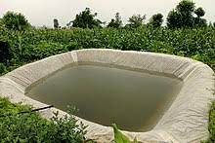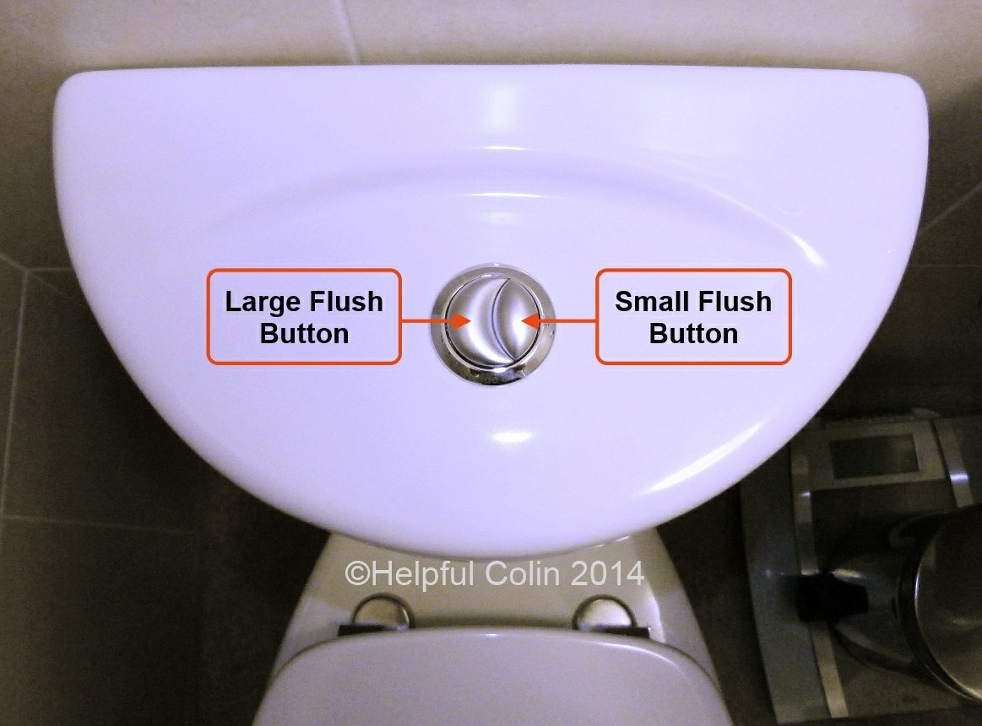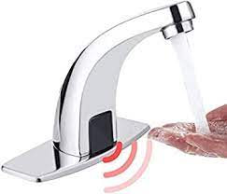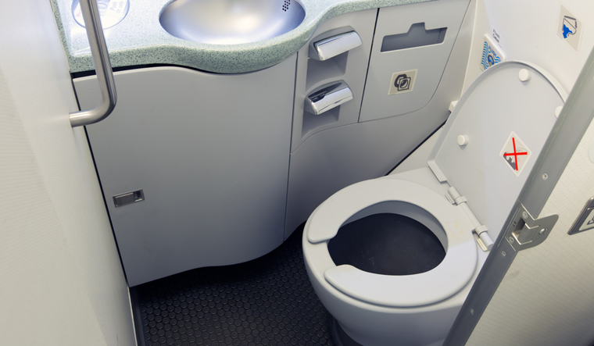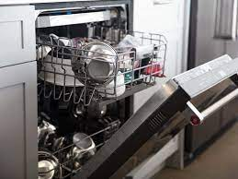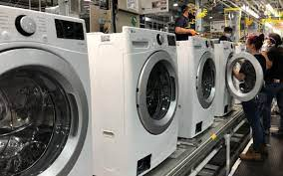

* **Blackwater** is the mixture of urine, faeces and flush water along with anal cleansing water (if water is used for cleansing) and/or dry cleansing materials.
* Water coming from domestic equipment other than toilets (e.g. Bathtubs, showers, sinks, washing machines) is called **greywater.**
* In conventional buildings, potable water turns to black or grey water and rain water runs off.
* But, in green buildings, potable water turns into greywater is recycled and used it again.
* Little portion of potable turned to black water and disposed off.
* Rain water is stored and used again.
* This is the system where water efficiency is achieved.
* The other aspects of water management in green building are the following:
  + 1) Rain water harvesting facilities to utilize the water for the services of the building are provided with sufficient capacity.
  + 2) Plumbing arrangement are done in such a way that potable water is used for potable purpose only.
  + 3) Dual plumbing is system adopted one for potable and other for recycled/flush water.
  + 4) The toilet shall be fitted with low water consuming flushes.
  + 5) Wash taps are controlled with motion sensors which reduces the use of water in unwanted times.
  + 6) Grey water from kitchenette, bath and laundry shall be treated and reused for irrigation or in cooling towers of air-conditioning.
  + 7) Water efficient toilets which use 2-3 litres of water for flushing compared to the conventional flushes.
  + 8) Vacuum toilets which normally used in aircrafts are becoming common in public rest rooms and commercial buildings.
  + 9) Waterless toilets (Composting toilets) which do not require water to transport human excreta. These toilets have pit or space below the toilet for composting excreta.
  + 10) Water efficient urinals are used in offices and hotels, theatres etc. use as less than 2.8 litres of water per flush. Most of them use oil barriers instead of water seal in flushes to prevent odour escaping from urine.
  + 11) Using water efficient appliances like washing machines and dish washers.